DSP In-Class Exercise “Fabric_AOI_2022”

Group 17

110522130 資工碩一 李信鋌

110526005 資工碩一 林季陽

The code we modified.

The code configurations to input raw data csv file and report filename

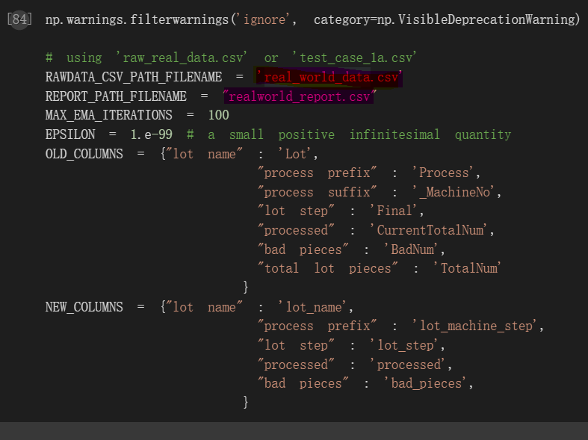

Edit the code in Run EM Algorithm v1.2.

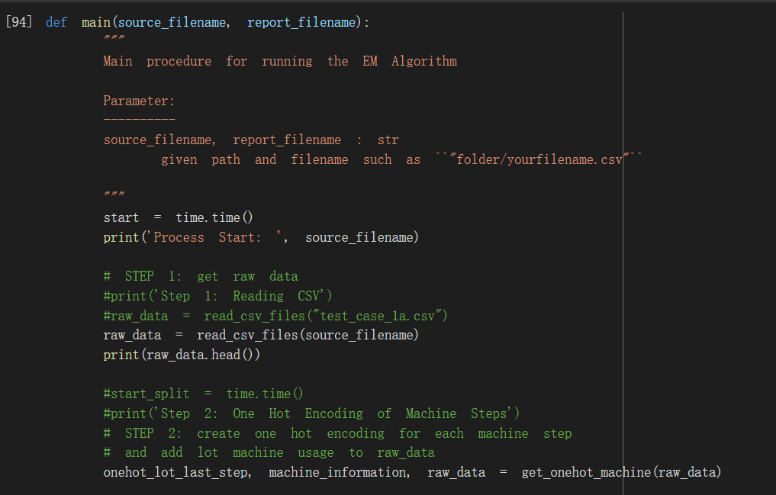

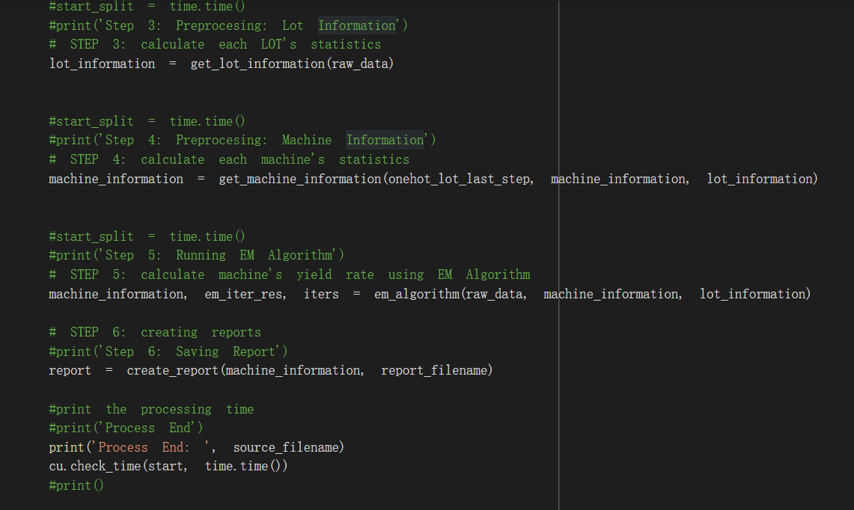

Result with real_world_data.csv

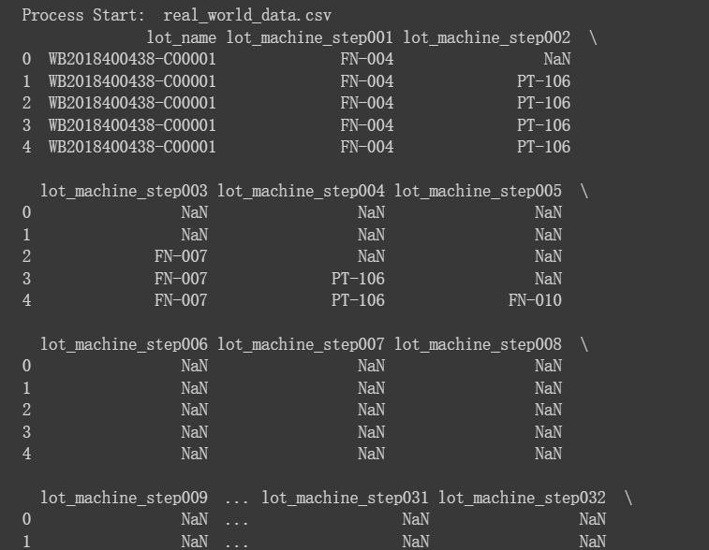

Result with test_case_1a.csv

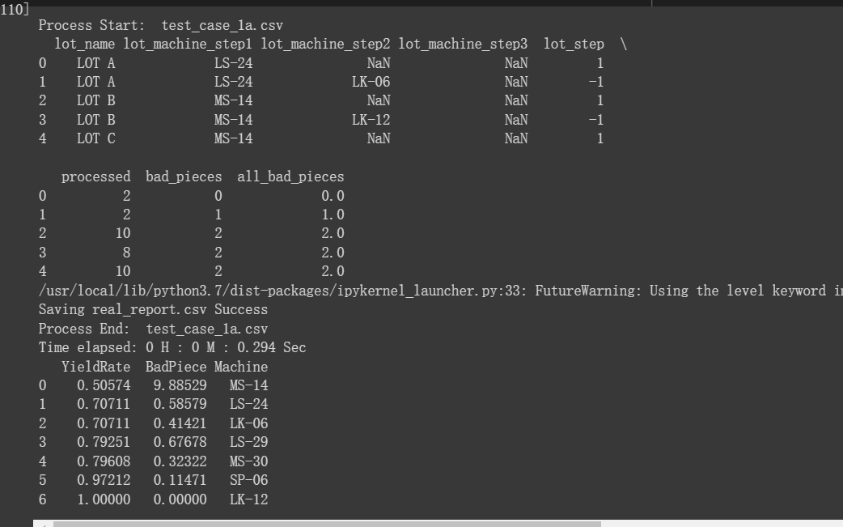

Explain the reason why we use the EM algorithm to estimate machine yield rate?

It is because the model may depend on unobserved latent variables, we need to use this algorithm to lower the affect of these variable to our model.

After the manufacturer has the result of machine yield rate estimation, what can they do using that result?

They can find which machine has a high bad piece rate. Therefore, they can maintain those broken manufacturing line to raise the yield rate and lower the bad piece rate.

What do we learn from this lab?

We learn the principles of EM algorithms, and how to use this algorithm to avoid latent variables affect our machine learning model.